The Bipedal Skeleton
Why was bipedalism selected for in early hominins and what are the physical differences of our bipedal skeleton compared with quadrupedal apes

The most significant feature of early hominin evolution was almost certainly walking bipedally.
Humans have only two small points of contact with the ground...our feet. They allow us to balance, but are not very efficient on slippery surfaces.
Why then was bipedalism selected for in Africa all those years ago?... (remember your paragraph from last week?)
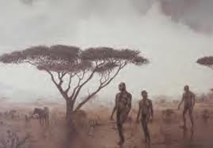
How could being bipedal in these environments offer a selective advantage?
Make a list of factors that are advantages of our bipedal nature and why they are advantageous.

Spot the difference:
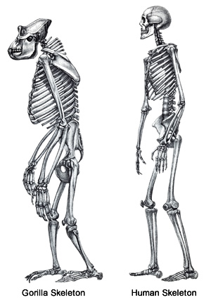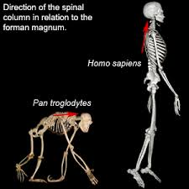

How does our bipedal skeleton differ to the gorillas quadrupedal skeleton?

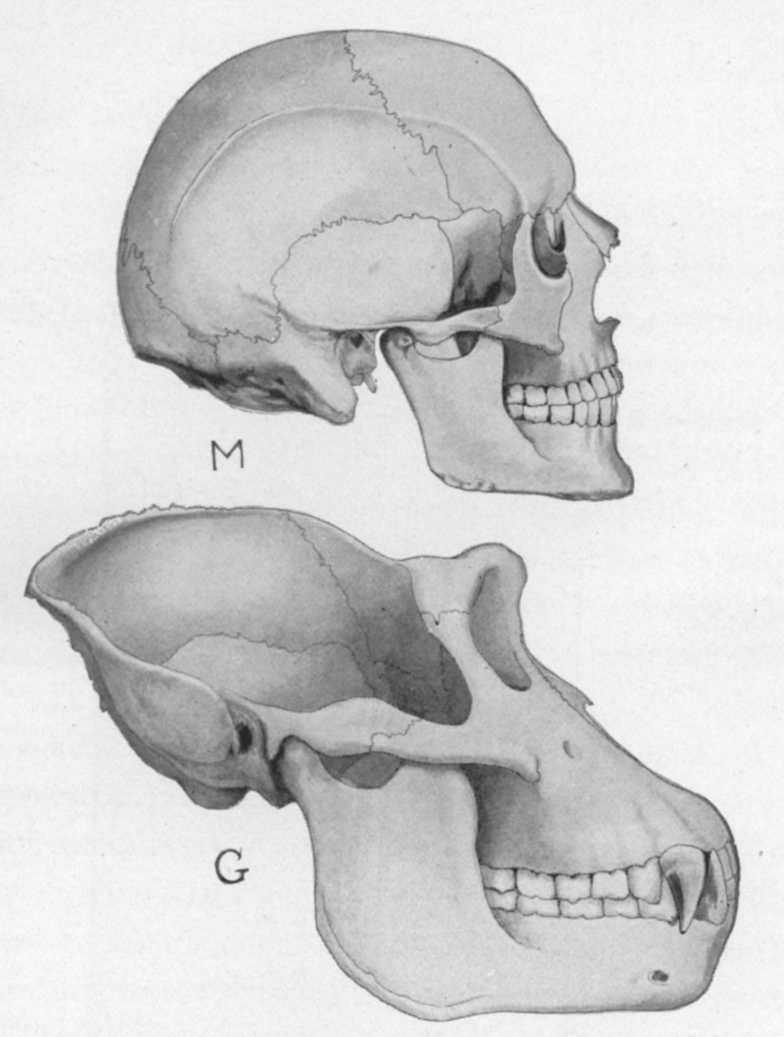
Spot the difference:
How does our skull differ to the gorillas skull?

Features of a homospaiens skull | Features of a gorilla skull

Other physical features of the skull that are commonly used to separate humans from our closest ape relatives include:

Interesting fact: The physical features listed above are, however, also found in baby chimpanzees and other immature apes, which suggests that human evolution has involved the retention of juvenile features within adults. This evolutionary process is called neoteny.

